STUDENT CASE FILE | CF-001
When a face does not finish one join
A complete, de-identified teaching record for the seven-lesson craniofacial research track

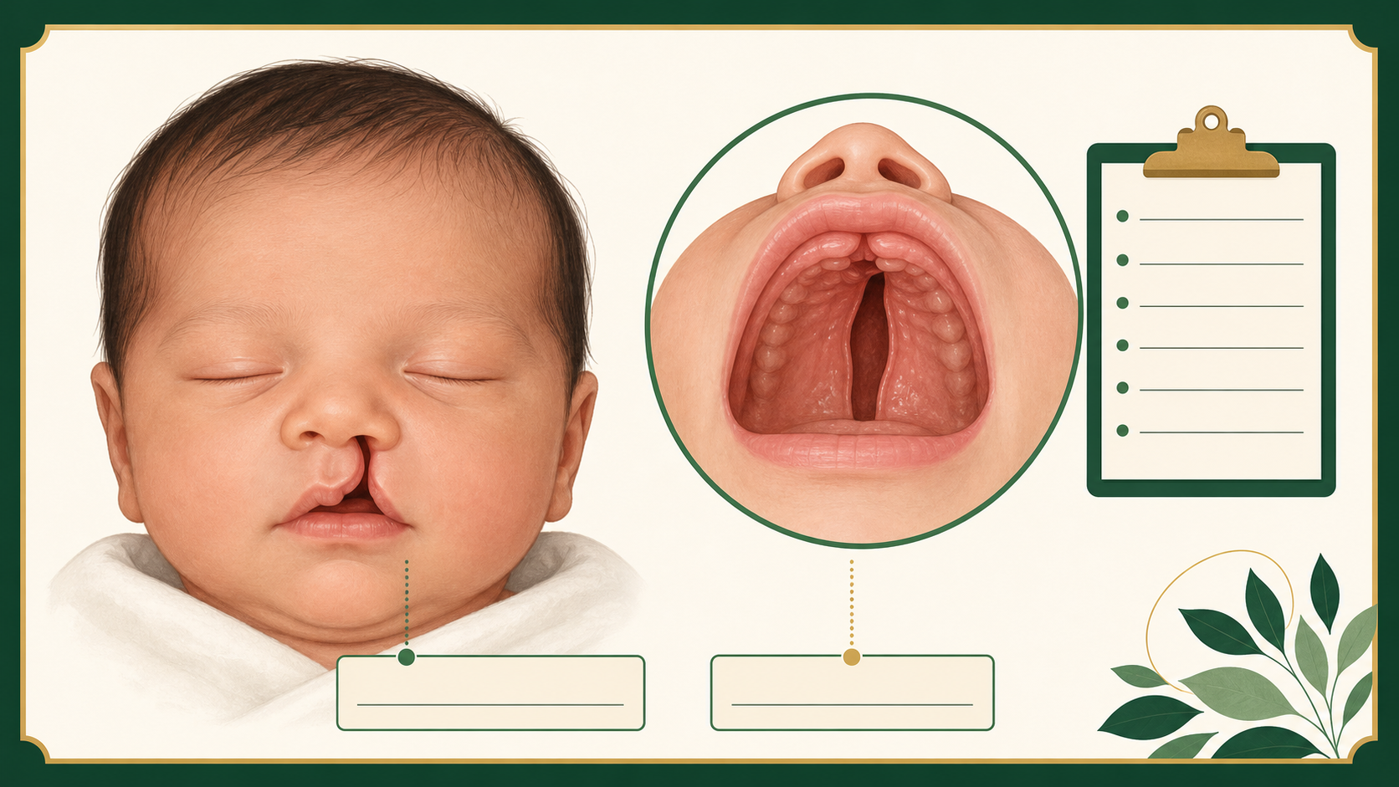
Illustration: composite observation record. The image is not a photograph of a real patient.
READ FIRST This is a teaching composite, not a real patient record. It contains no name, date of birth, address, or diagnosis. The case gives you enough evidence to reason, but not enough evidence to diagnose.

Case code | CF-001
Record type | Composite developmental biology case
Observation window | Early development, reconstructed from the developmental timeline
Source type | Teaching synthesis from published craniofacial biology

1. The presenting observations
A newborn teaching case is described with two observations: an opening in one side of the upper lip and an opening in the roof of the mouth. The record does not assign a diagnosis. Your job is to identify the developmental step that could explain each observation and to name the next evidence you would want.
KNOWN Two structural observations are recorded. The timing of facial development matters.

UNKNOWN The exact cell behavior, pathway, gene effect, and developmental time point that changed.

Do not jump from an observation to a cause. First separate what you can see from what you still need to test.

Socratic opening questions
- Which words in the record are observations rather than explanations?
- What must have happened for two tissue edges to become one continuous surface?
- Which missing fact would most change your next question: location, timing, cell behavior, or gene activity?

2. Developmental timeline
Use this timeline as the unit clock. It is intentionally broad: the goal is to reason about sequence and timing, not to memorize one exact day.
Window | Building step | Question to carry
Weeks 4-5 | Facial prominences form and grow. | Where are the parts before they join?
Weeks 6-7 | Upper-lip and primary-palate regions approach and fuse. | What must meet, and when?
Weeks 8-12 | Palate shelves elevate, contact, and remodel the seam. | Is the issue growth, contact, or remodeling?
Across windows | Cells move, change identity, and respond to signals. | Which cell behavior is the next test?

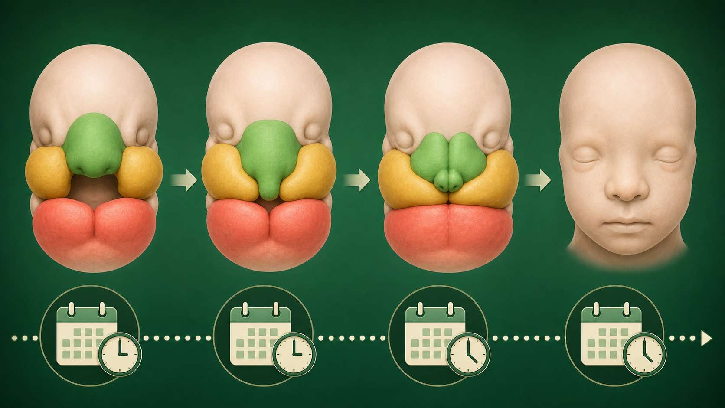
Figure 1. A simplified face-building sequence. Arrows show order, not exact scale.
DECISION POINT If a structure is present but an opening remains, decide whether the stronger first hypothesis is insufficient growth, missed contact, or failed remodeling.

3. Evidence cards
Each card has a claim ceiling. The ceiling tells you exactly how far the evidence lets you go. A good scientist stops at the ceiling and writes the next test.

IRF6
IRF6 is a gene. Its protein helps epithelial and periderm cells behave correctly during developing lip and palate tissue.
CLAIM CEILING This card supports a question about cell behavior and fusion conditions. It does not diagnose CF-001 or prove that IRF6 is the only cause.

WNT9B and WNT signaling
WNT9B is one gene linked to signaling pathways that help position and time facial patterning.
CLAIM CEILING This card supports a question about a cue, location, or timing window. It does not assign blame to a family or a single gene.

SOX10
SOX10 can be used as a marker to follow neural crest populations in a model embryo.
CLAIM CEILING A marker shows where a population is or how it changes. It does not, by itself, prove what caused the change.

WNT, RUNX2, and SOX9
A cell-fate decision uses interacting gene programs. WNT/β-catenin can support an osteogenic path, while SOX9 is associated with a cartilage path; RUNX2 helps support bone programs.
CLAIM CEILING The useful claim is that cues and internal state bias a choice. It is not a single magical switch.

TGFB3
TGFB3 signaling is studied in palatal fusion and medial epithelial seam remodeling after the shelves contact.
CLAIM CEILING This card lets you separate growth, contact, and remodeling. It does not make every cleft a TGFB3 story.

4. Visual evidence dossier
Use the figures as evidence cards. Label the step you see, then write one sentence that stays within the claim ceiling.
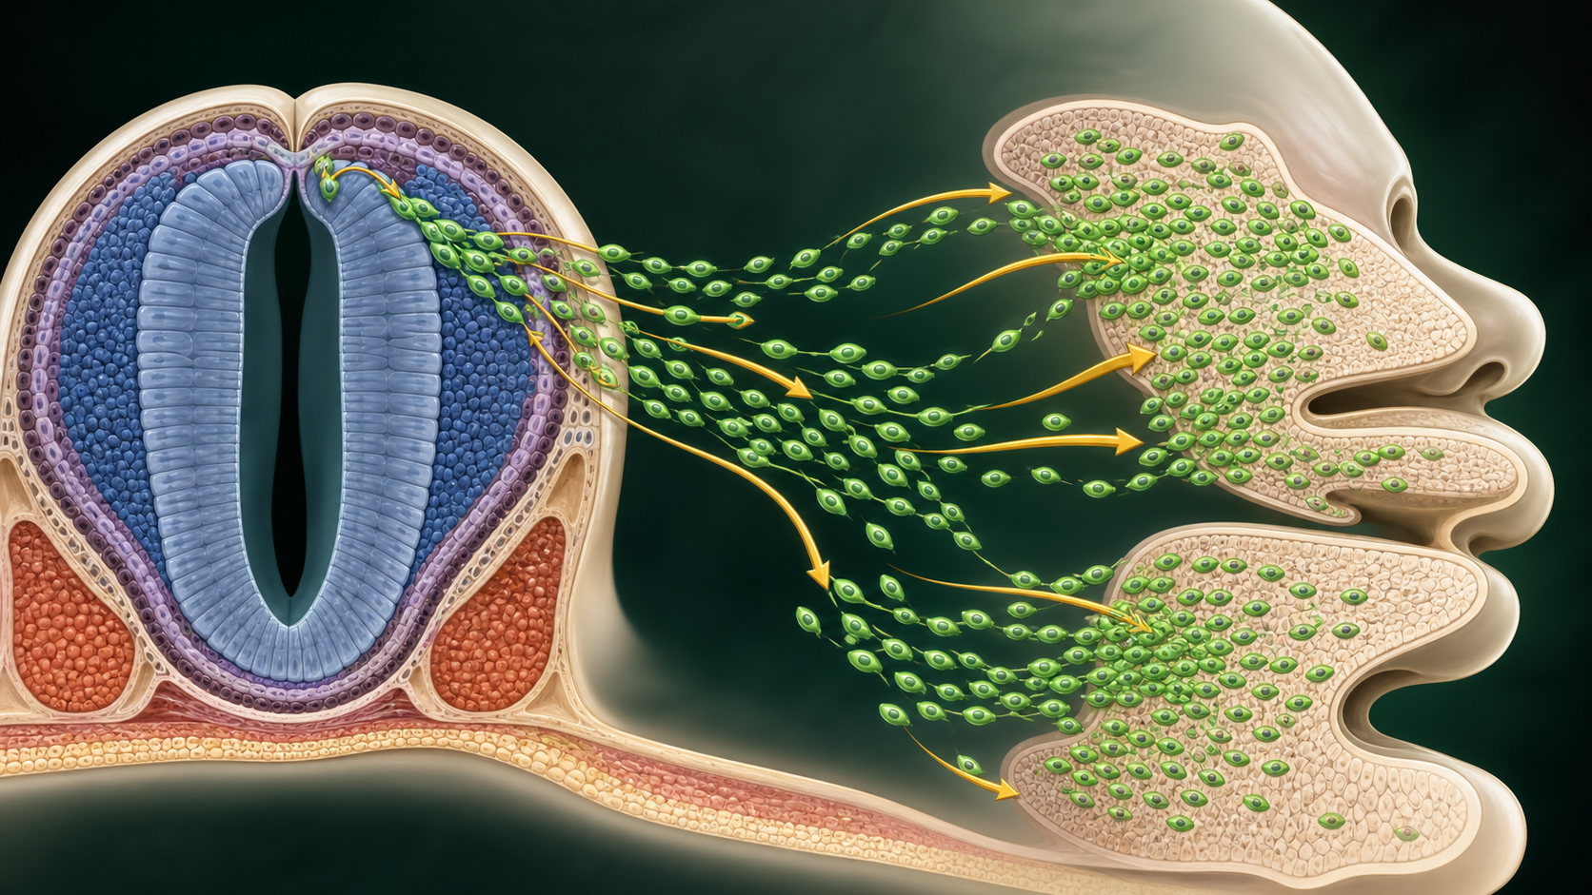
Figure 2. Neural crest cells begin in one region, migrate, and contribute to facial tissues.
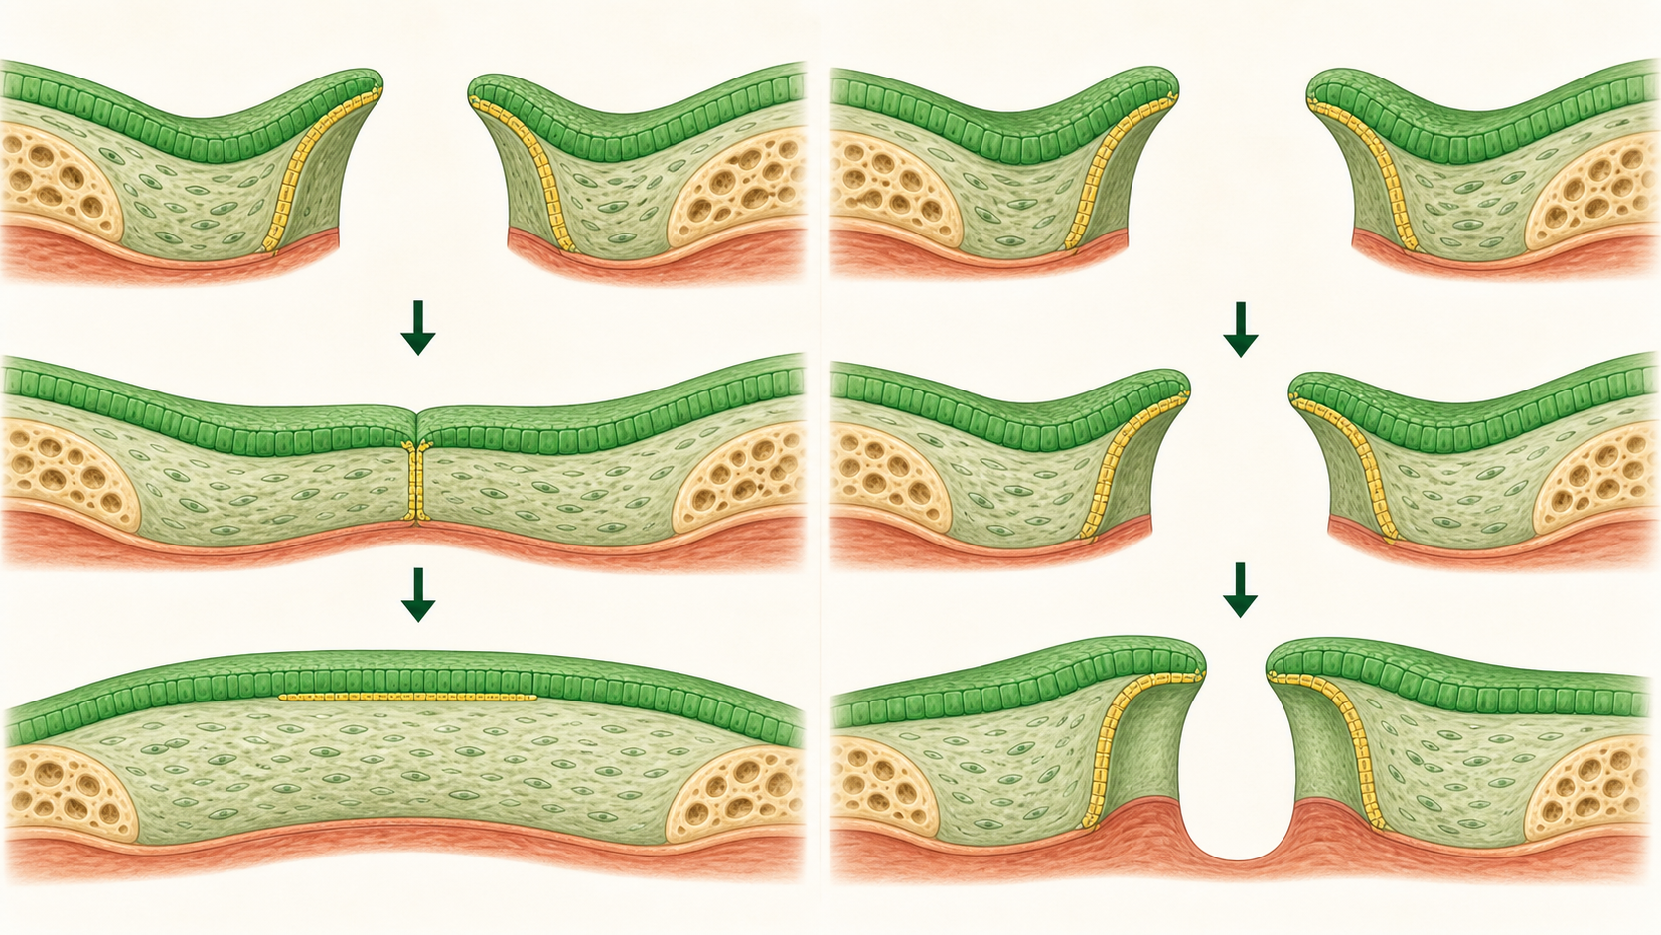
Figure 3. Contact and a remaining gap are different observations.

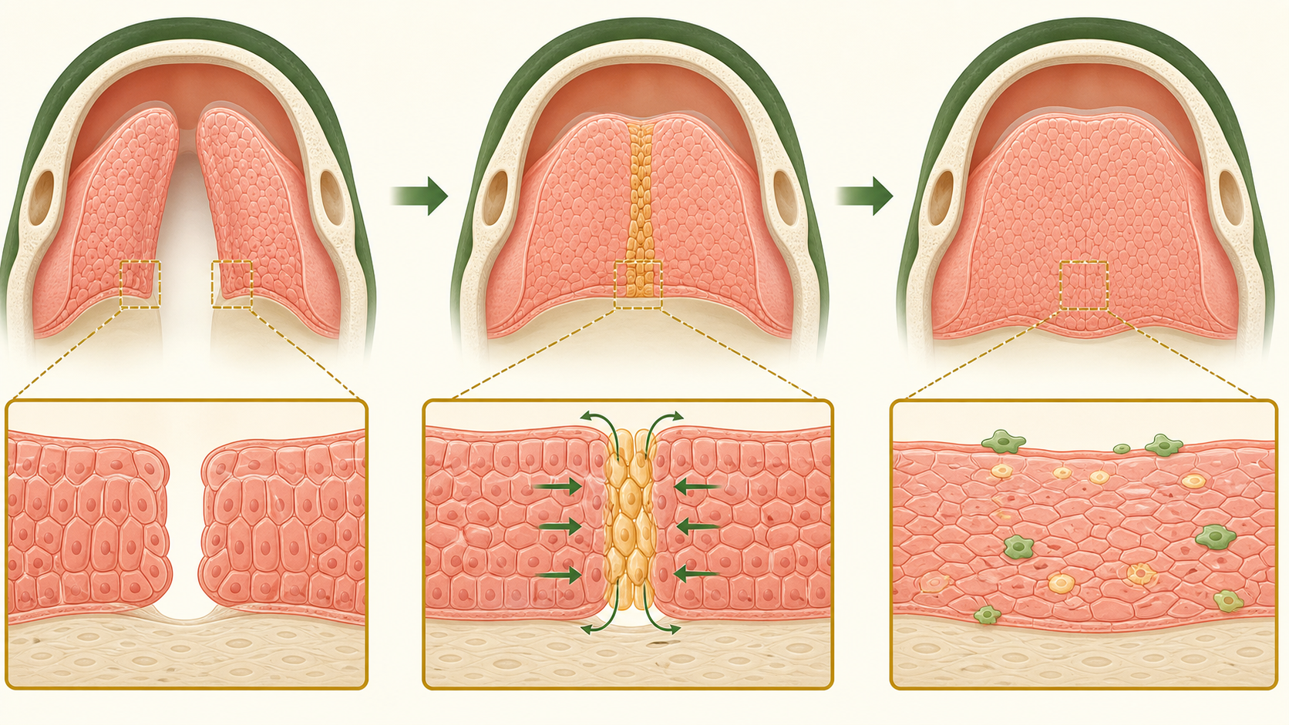
Figure 4. After contact, the seam must be remodeled for a continuous surface.
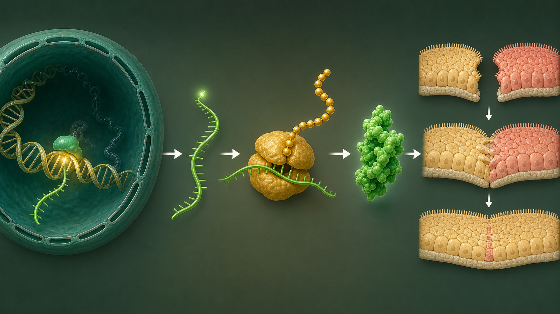
Figure 5. A gene instruction becomes RNA, protein, and cell behavior.

5. Case board: make the next decision
Work from the record and evidence cards. You do not need a live web search. Your answer should name a process, cite one supplied card or figure, and state what the evidence cannot tell you.
Observation | ____________________________________________________________
Developmental process | ____________________________________________________________
Evidence card or figure | ____________________________________________________________
Decision | The strongest next test is _____________________________________
Reason | Because ______________________________________________________
Claim ceiling | This evidence does not let me conclude ________________________
Next question | ____________________________________________________________

UNIT BOUNDARY Everything needed for the seven lessons is in the decks, this case file, and the student explainer pack. Web sources are enrichment only.

Sources for enrichment
The seven lessons are self-contained. These links are for optional teacher or student follow-up, not required homework.
- National Institute of Dental and Craniofacial Research, Cleft Lip and Palate: https://www.nidcr.nih.gov/health-info/cleft-lip-palate
- Craniofacial development review, PubMed Central: https://pmc.ncbi.nlm.nih.gov/articles/PMC3039913/
- Cranial neural crest and facial development review, PubMed Central: https://pmc.ncbi.nlm.nih.gov/articles/PMC11072871/
- IRF6 and epithelial seam biology, PubMed Central: https://pmc.ncbi.nlm.nih.gov/articles/PMC2659566/
- Palatal fusion and seam remodeling review, PubMed Central: https://pmc.ncbi.nlm.nih.gov/articles/PMC3552505/

